Report on CSC3050 Project 1
The report consists of the six logic codes: add.s, add_extra.s, and.s, beq.s, required.s, sll.s., as well as their result and implementation. Also, the naïve function that needs to be optimized is also concluded, as well as its runtime.
Part I: implementation of logics
This part is relatively easy. The implementation of and.s is included in the project manual, so I just followed the way and completed all the works. The pictures below shows my implementation and their result.
Add.s:
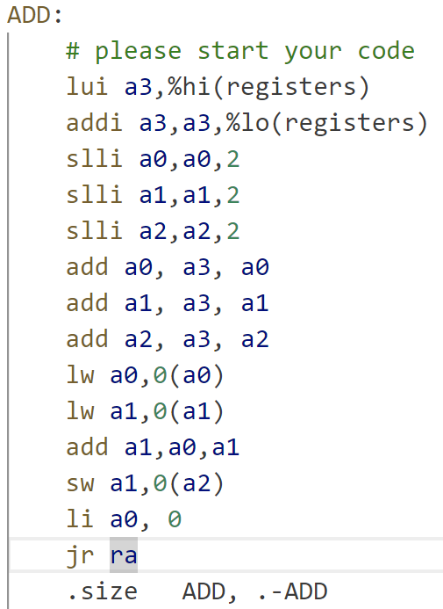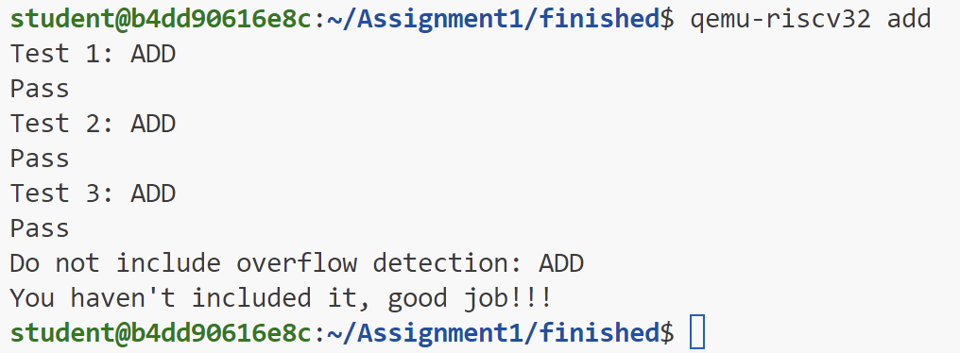
Add_extra.s
Here, to detect overflow, I implemented a method to look at the first bit of both added numbers. If two positive numbers result in a negative number, then there is a overflow and vice versa.
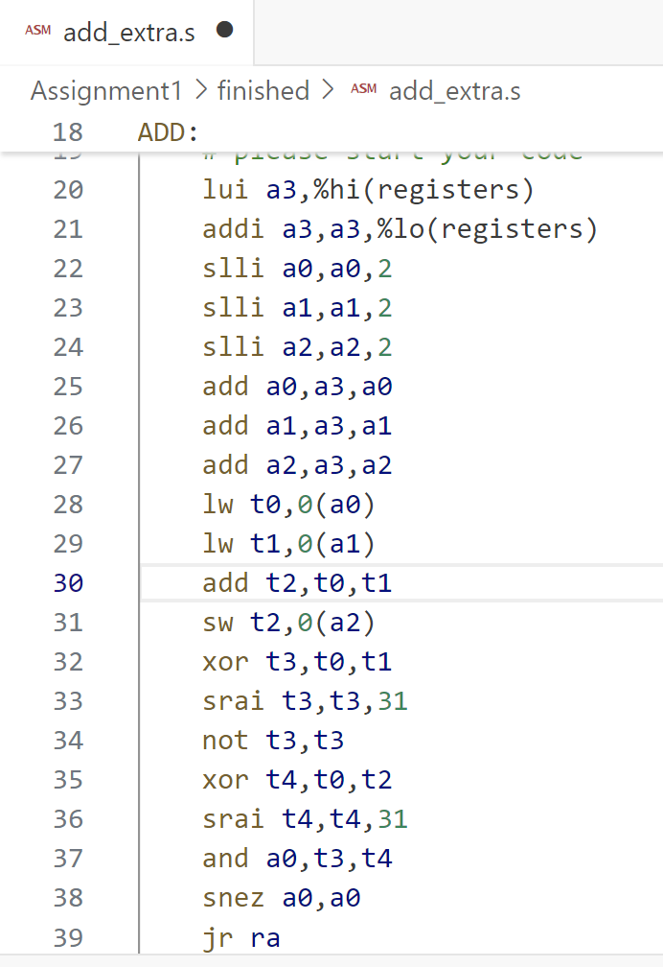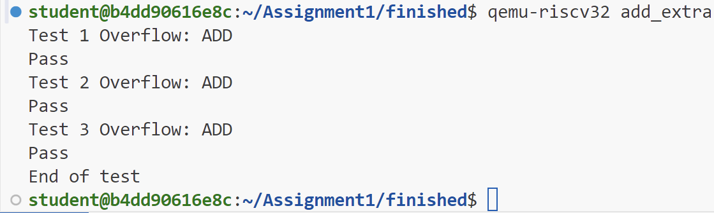

And.s
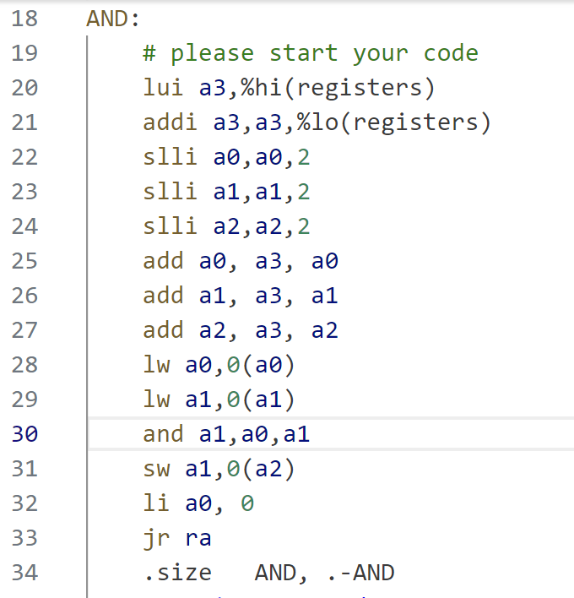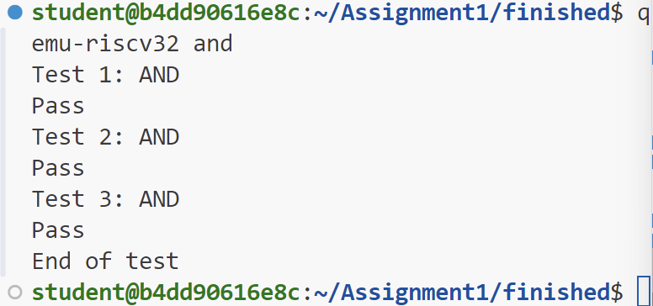
Beq.s: return 1 if equal, return 0 if not equal
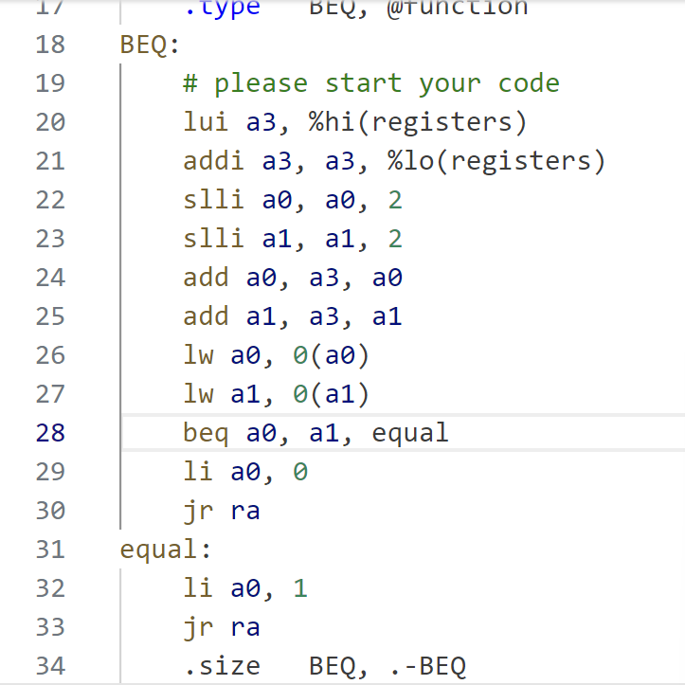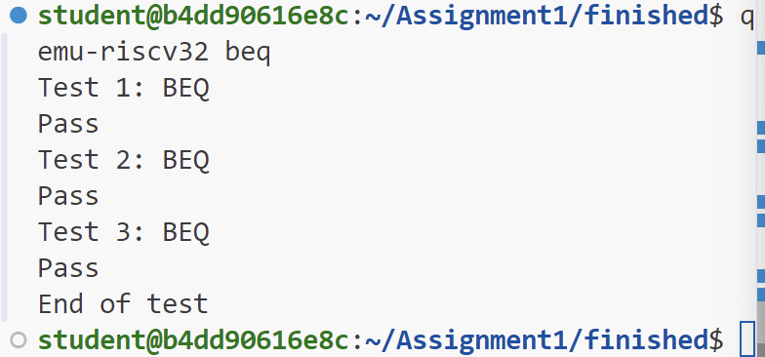

Required.s
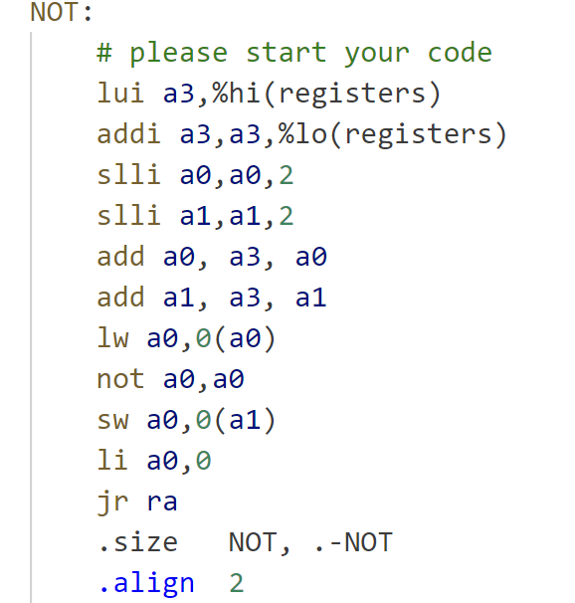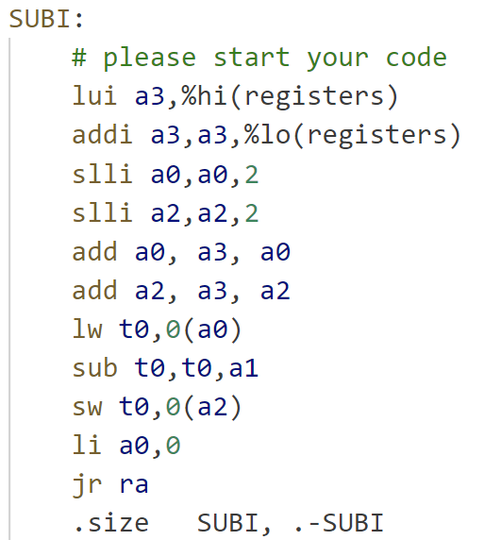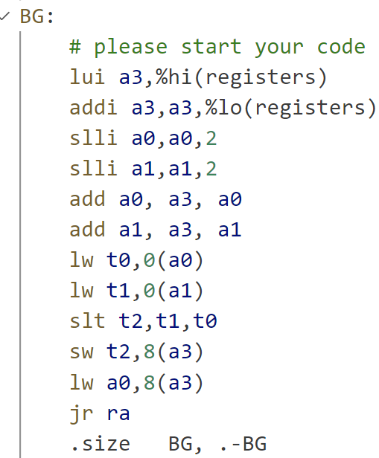
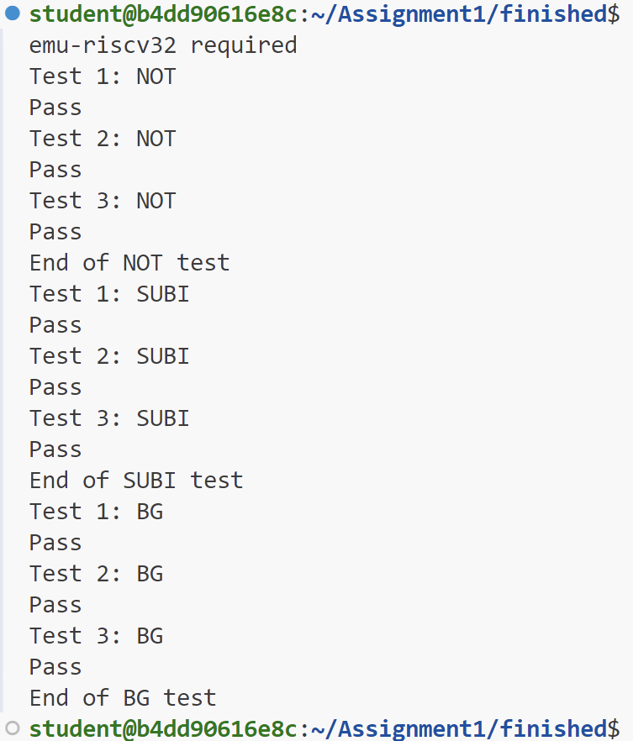
sll.s
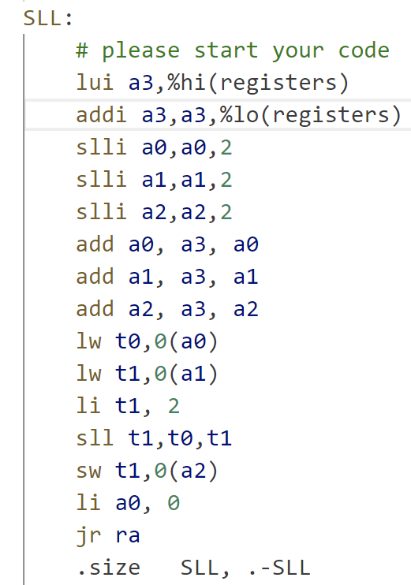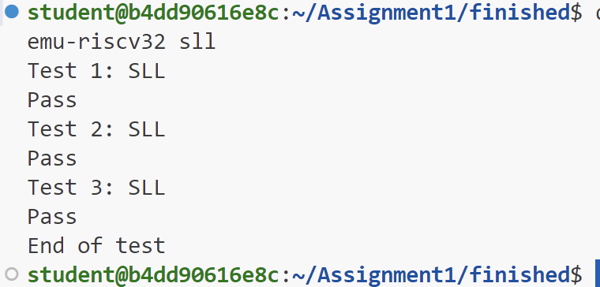
Therefore, all implementations are done.

Part II: Optimizing a program
This program is about printing prime numbers from 2 to 100000. I first checked its original time and the time after extending the range to 1000000, the result is shown below.
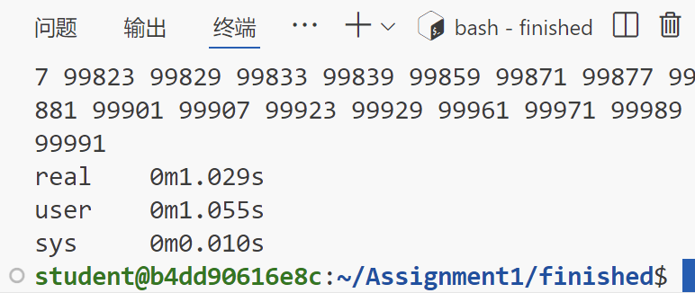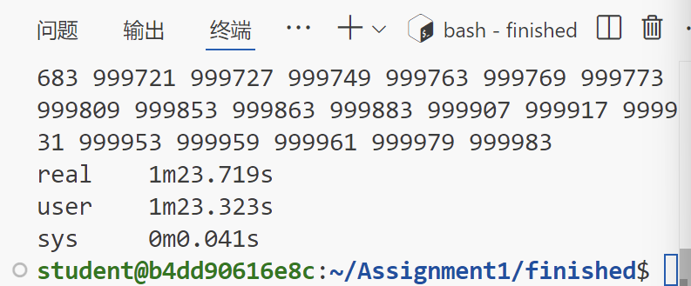
The range extension code is shown below. (Only line 63 is modified.)
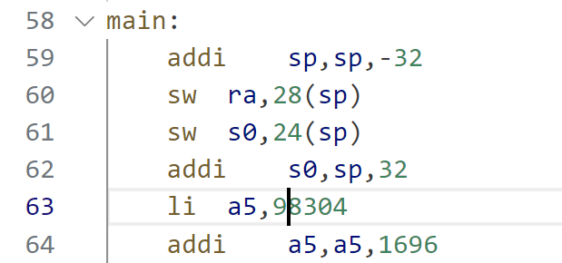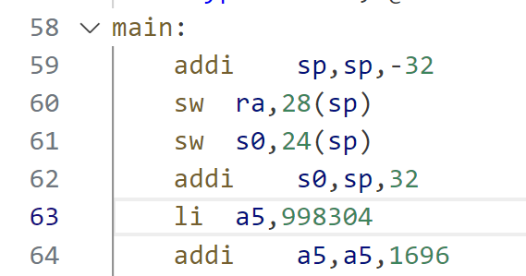
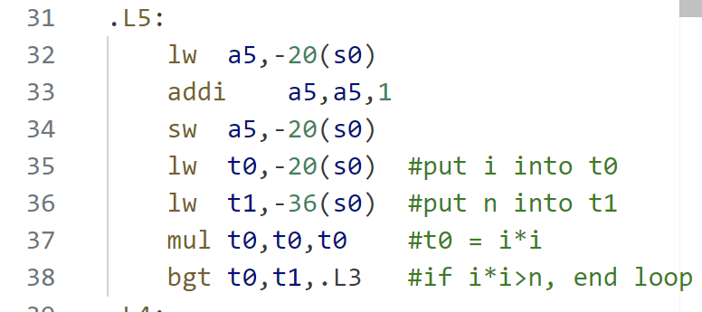
It is obvious that the program runs a long time. To reduce runtime, I added four lines in the .L5 part, which is originally used to add one on the dividing number during the prime number test. When the dividing number reaches the square root of test number, the test number is automatically considered a prime number, which reduces the time complexity from O(n^2) to O(n^1.5) and greatly saves time. The code I added is shown below.
After adding the codes, I re-tested the runtime, and it turned out that the runtime is significantly reduced.
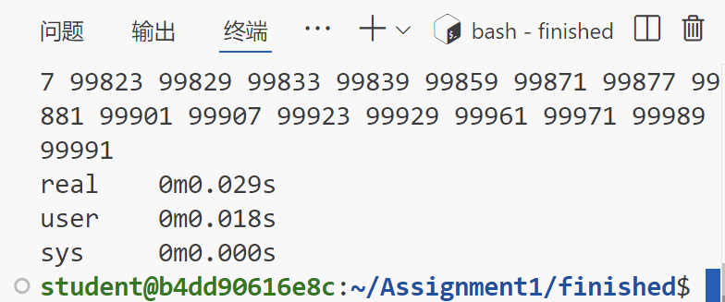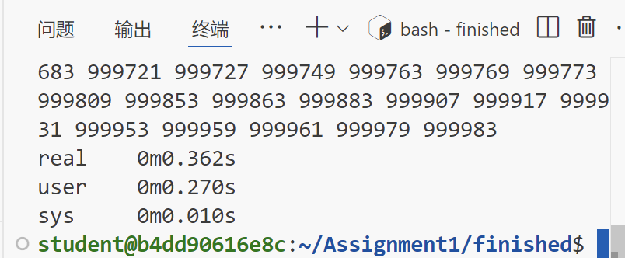
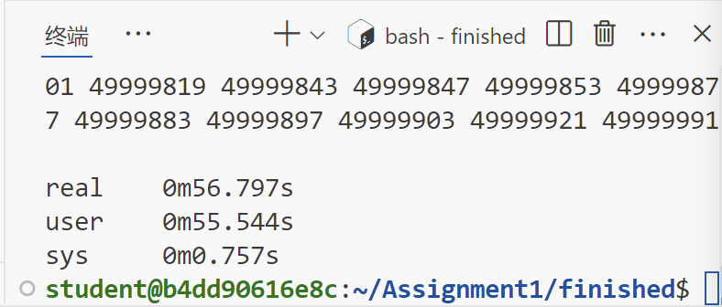
I also tested a bigger range. The previous time used for 1000000 range can now be used for 50000000, which is a 50 times improvement.

